**Inn Rooms**

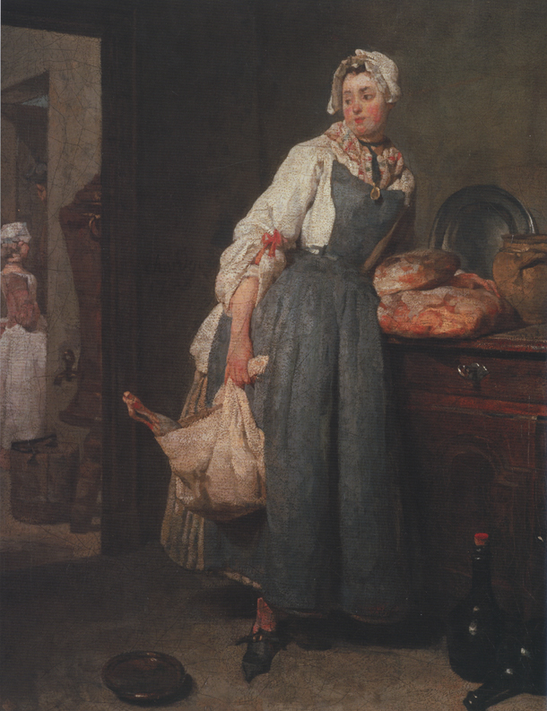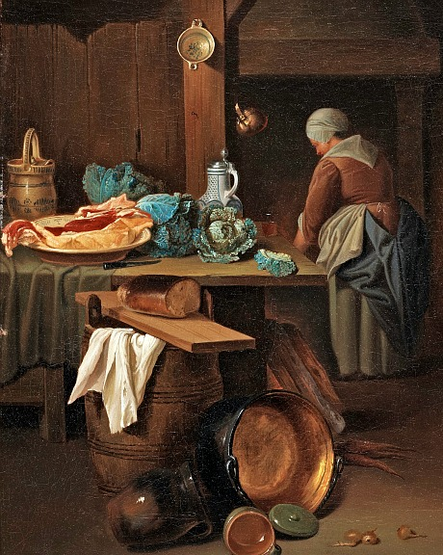Lower-class areas should be cluttered, with barrels and buckets used as makeshift tables and items strewn about the place. Kitchen should be appropriately messy with various food items spread over it in mid preparation.

Most scattered items should be close to furniture or large ‘blockers’ so that the player doesn’t have to worry about navigating past every pot or bottle lying on the floor.

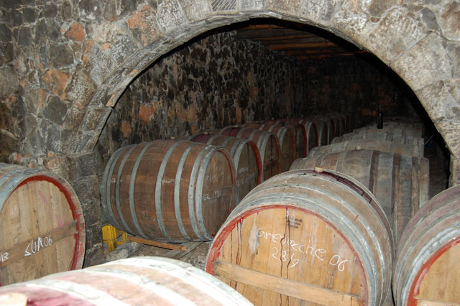

Most rooms in the Inn will have their own supply of beer, either from a stockroom behind the bar or situated at the bar itself. The Inn is large and features many different ‘bar areas’ so it would be necessary for the barkeeps to have easy access to their own mini cellars. These could be used as hubs between the rooms themselves, or as ways to get between interior and exterior sections (through the cellar door).

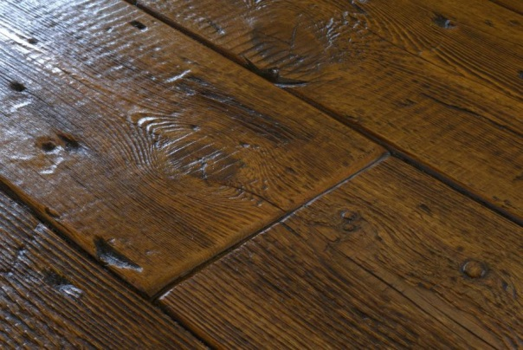Core colours for interior walls & floor (due to torchlit/candlelit locations).

Floorboards should be rustic looking and worn. Mixtures of shades should be used to get the impression of floorboards having been replaced over the years of service.

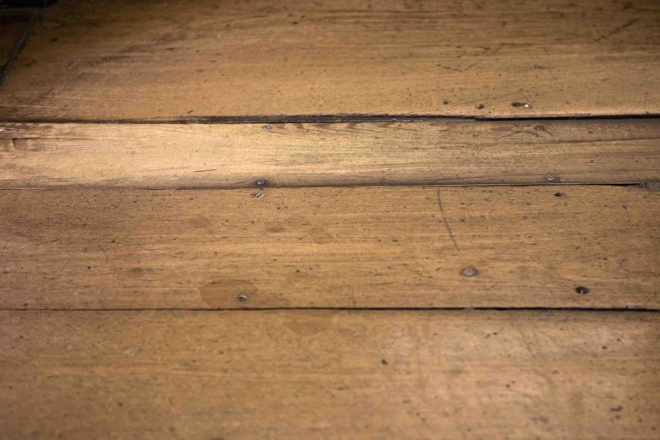

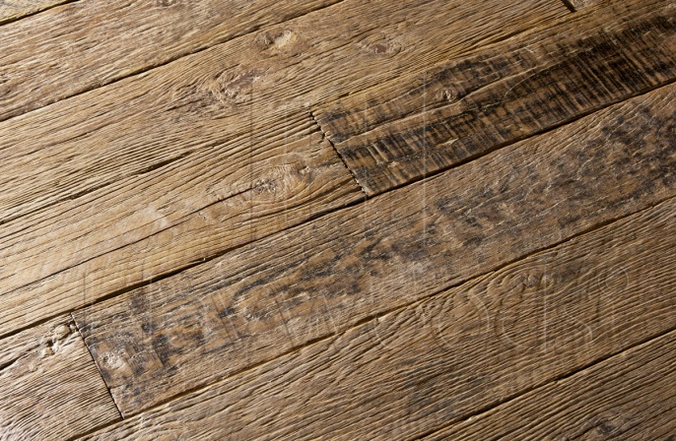

Planks are irregular lengths and have some blemishes.

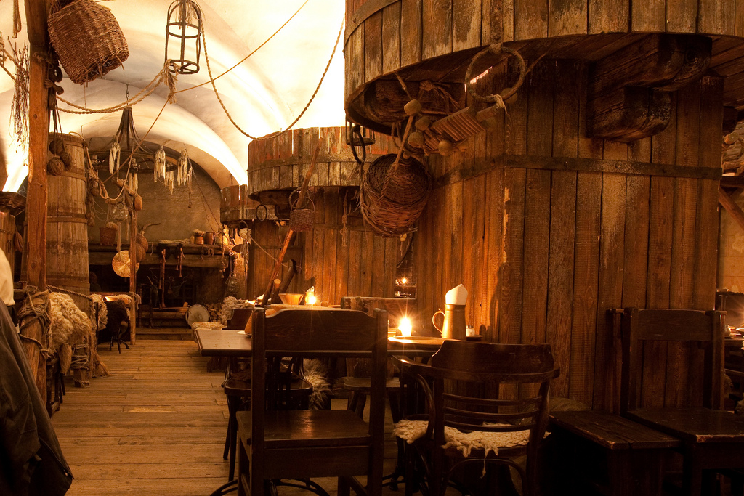Example of candlelit interior and the general clutter present in an Inn of this nature. Note all the hanging items and items not being used just put to the side (such as some of the chairs).

*Isometric Interiors*

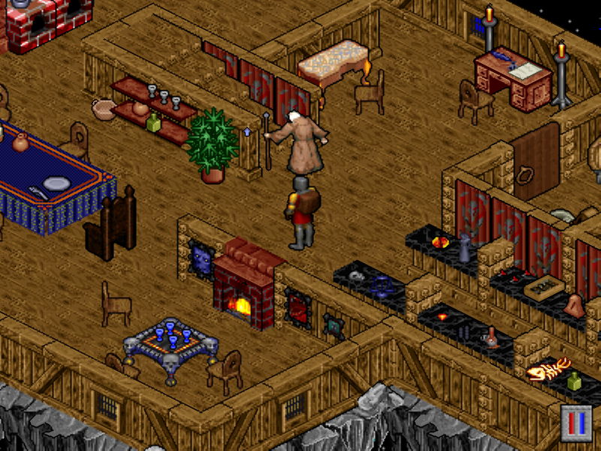As a reference for building rustic buildings in an isometric format, here are some examples from the games Pillars of Eternity, Ultima 8 and Ultima Online:

Even though no shadows or lighting are present, the scene feels like it has the interior candlelit glow through the use of the colour palette.

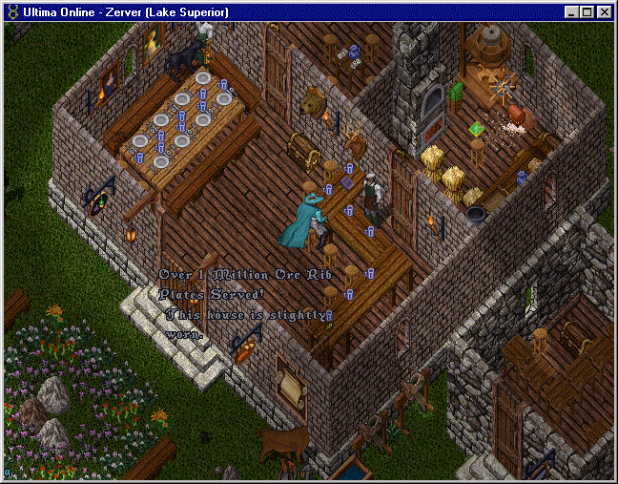

Here is an example of the kitchen clutter mentioned above being used to effect in this tavern. The flour sack and food items on the table in the kitchen add to the sense that the tavern is currently in use. Also note the irregular plank effect on the floorboard (achieved despite the game using set-resolution tiles).

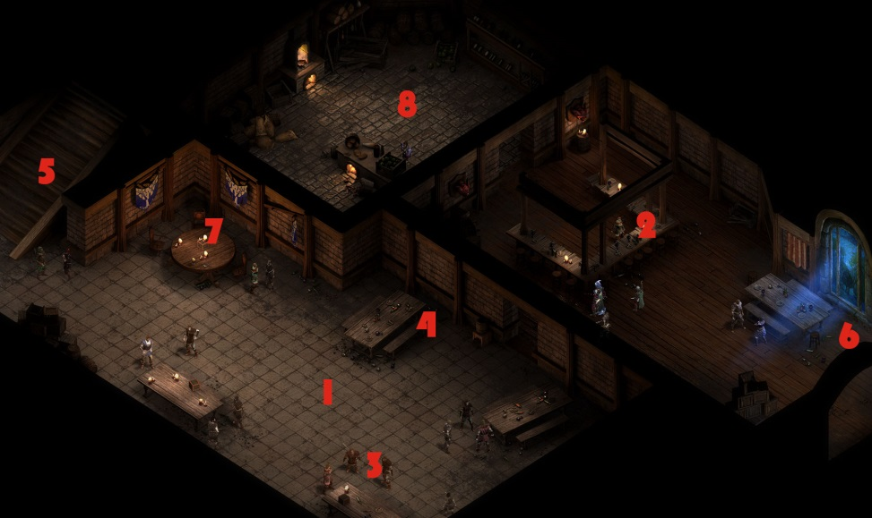Set decorations such as the torch brackets, chest & mounted trophies help bring the scene together as well as a lived in place with a history.

This is the ideal lighting conditions of the interior scenes; slightly moody and a real sense of warmth and heat from the particularly lit up areas. Note the different floor types being used to separate the different rooms.

**Characters**

*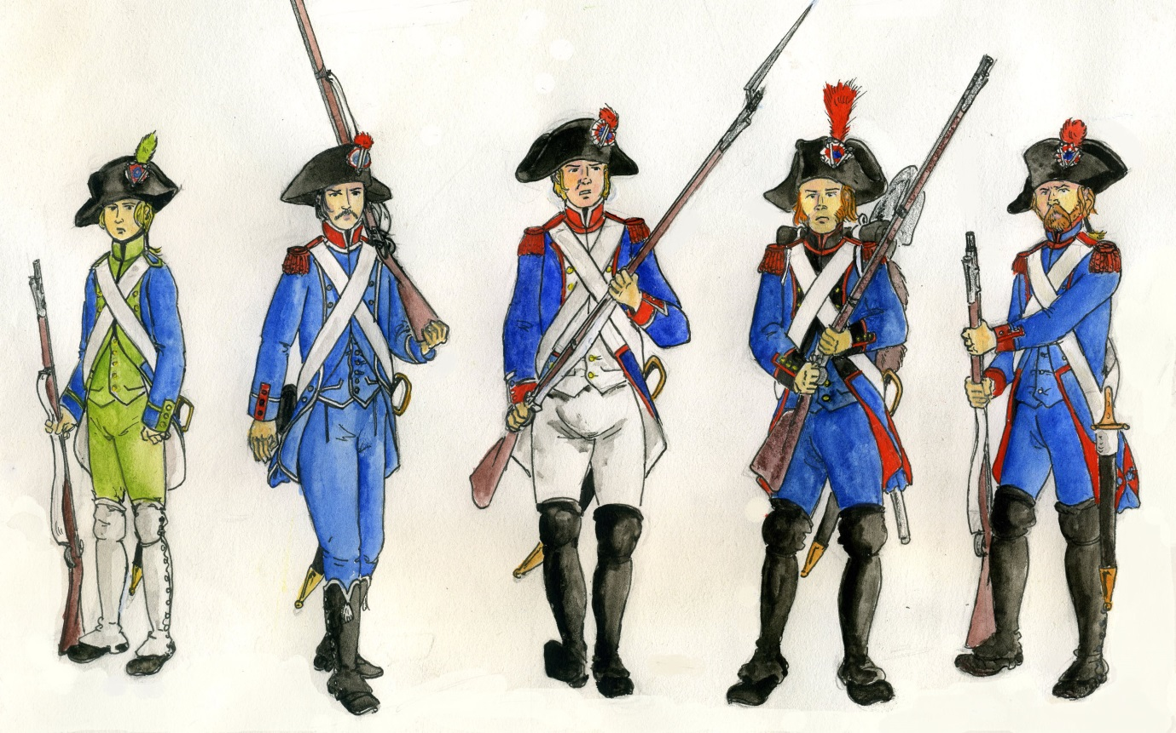Revolutionary soldiers (“The Blues”).*

These characters will be identified onscreen predominantly by their blue attire. Any character wearing this particular shade of blue should be considered a friend of the Republicans or a Republican soldier.

*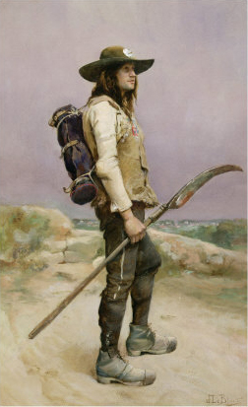Vendéan soldiers & commoners.*

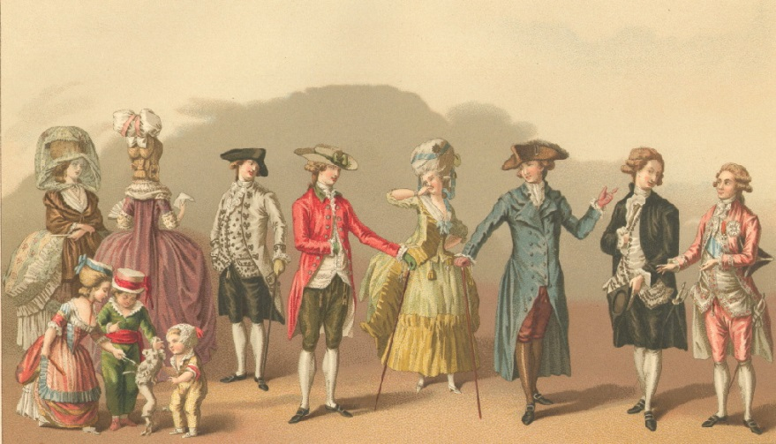The Vendéan army mostly comprised of commoners. Their men frequently went to battle in their standard clothes and wielded peasant weapons. The defeated soldiers therefore would simply look like common folk, so anyone in the tavern not wearing Republican blue can be considered relatively neutral towards the player.

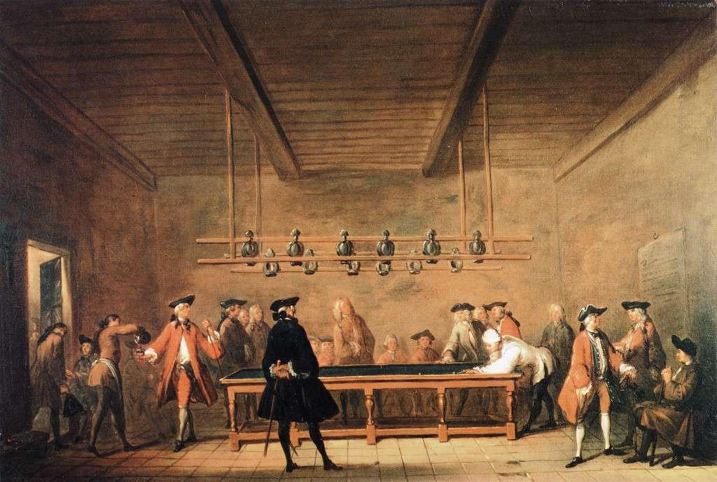

In the more upper-class parts of the Inn the nobler looking townsfolk will be found. They will frequently carry a walking stick and wear the popular tricorn hat. Billiards was a popular game amongst the well-off.

**Props & Furniture**

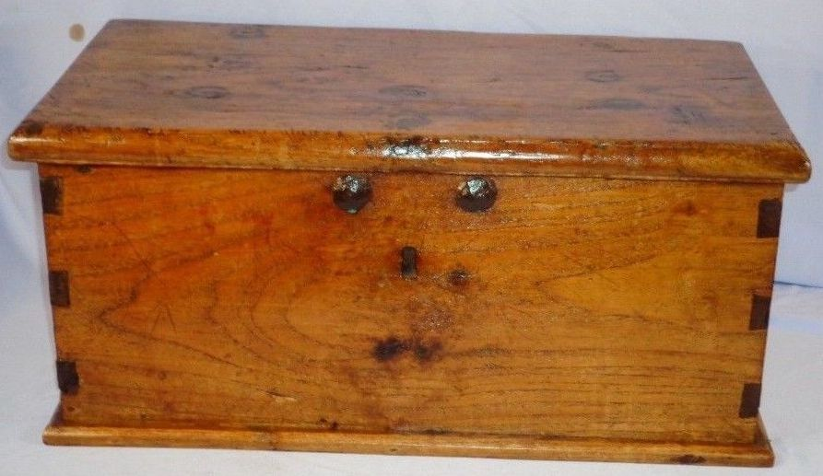Following are some examples of commons props and furniture which would be found in an 18th century Inn.

